Experiment 11: Creation and execution of procedures

Command:

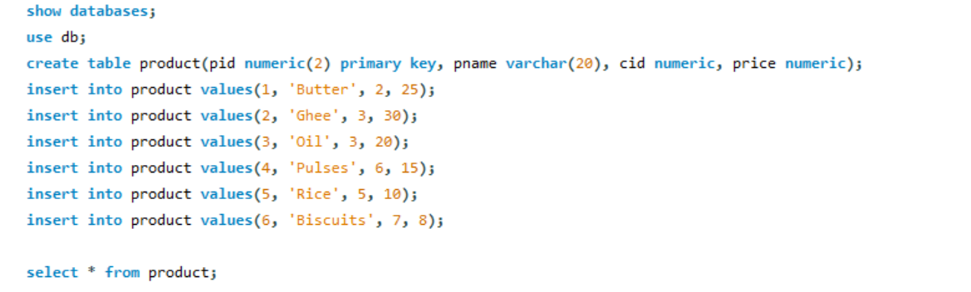

Output:

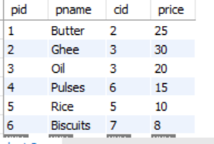

Command:

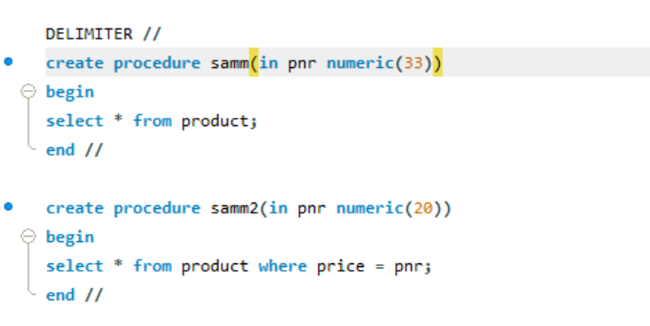

Output:



Command:

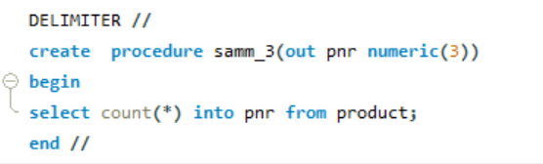

Output:



Command:

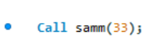

Output:

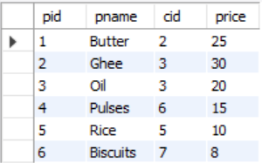

Command:

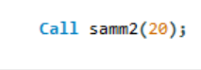

Output:

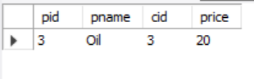

Command:

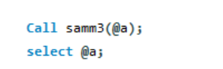

Output:

